# HT Assignment – 4 (Meghanath P.)

## Task – 1: Database Design

* Design a SQL schema for a Courier Management System with tables for Customers, Couriers, Orders, and Parcels. Define the relationships between these tables using appropriate foreign keys.
* Requirements:

• Define the Database Schema

• Create SQL tables for entities such as User, Courier, Employee, Location,Payment

• Define relationships between these tables (one-to-many, many-to-many, etc.). • Populate Sample Data

• Insert sample data into the tables to simulate real-world scenarios.

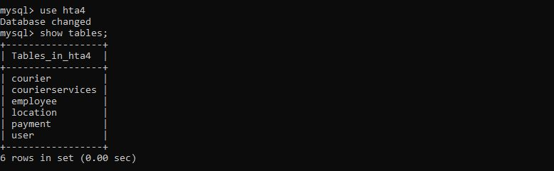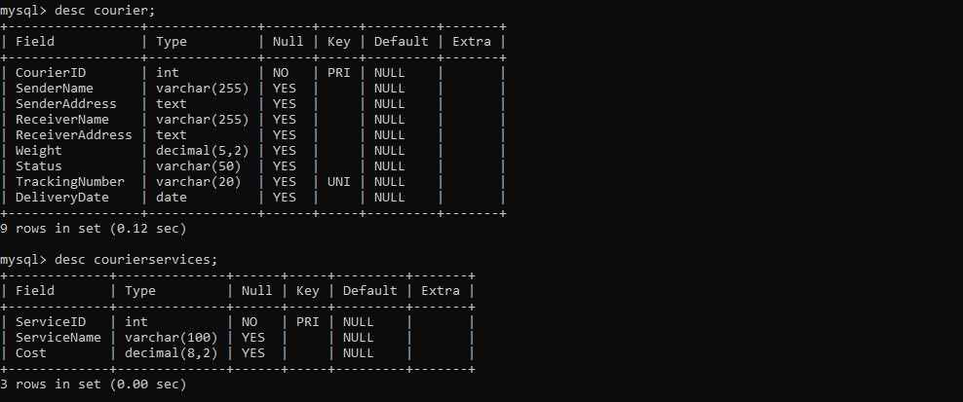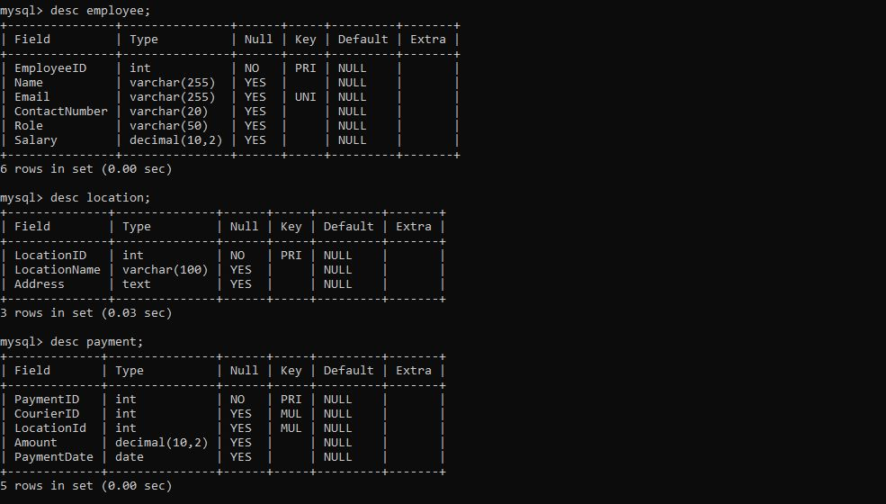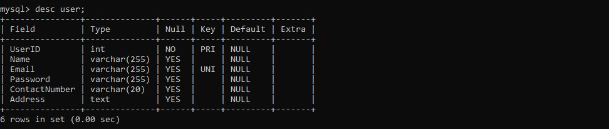

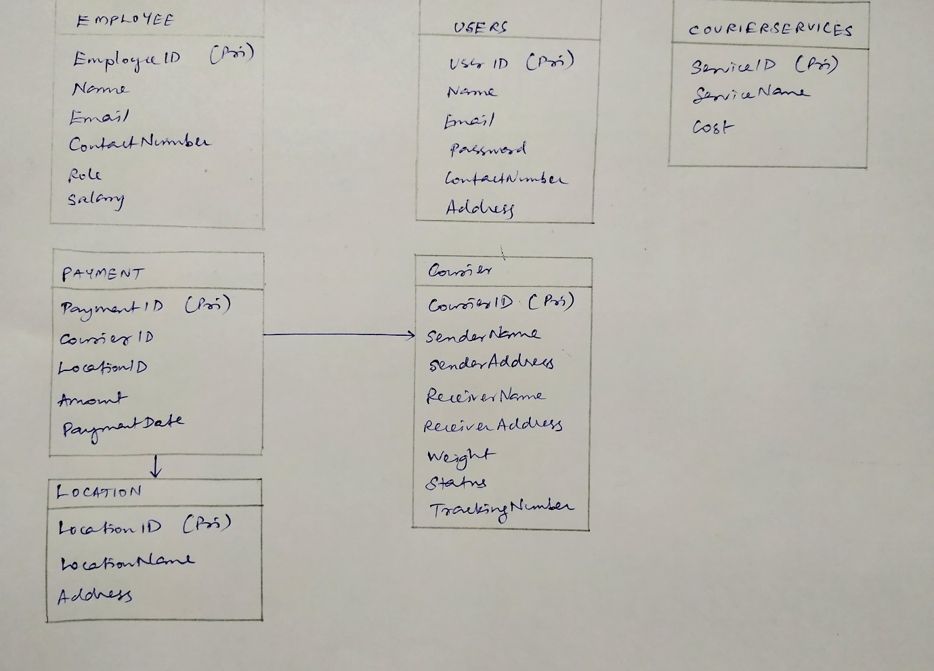

## Task – 2: Select, Where

1. List all customers

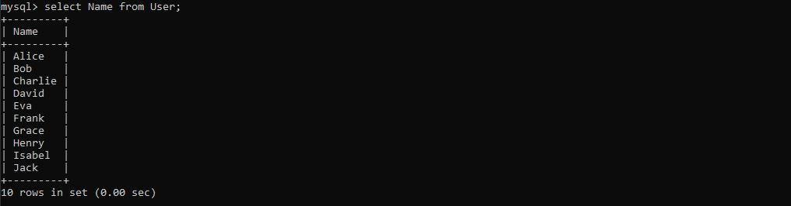

1. List all orders for a specific customer

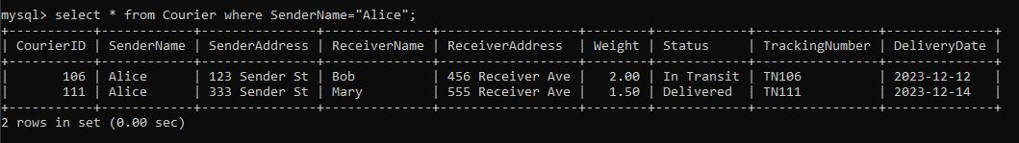

1. List all couriers

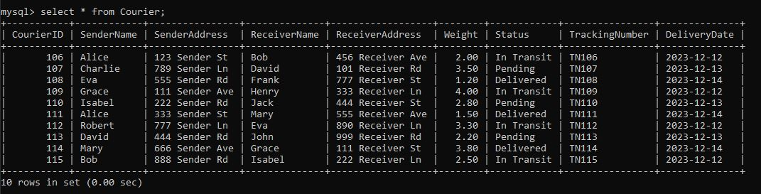

1. List all packages for a specific order

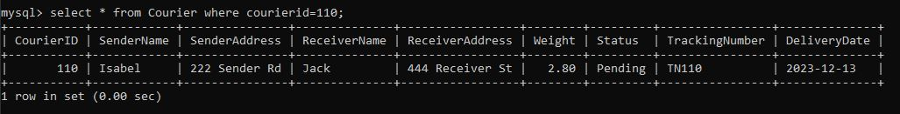

1. List all deliveries for a specific courier



1. List all undelivered packages

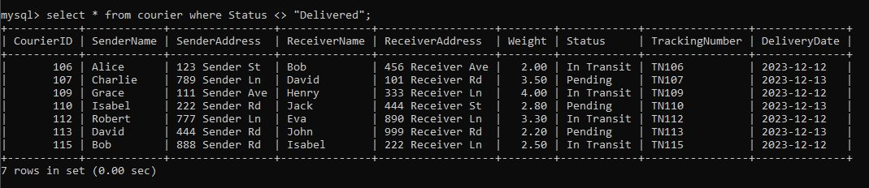

1. List all packages that are scheduled for delivery today

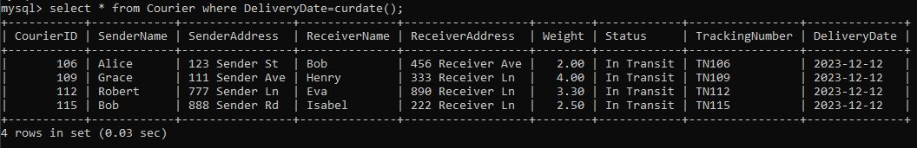

1. List all packages with a specific status

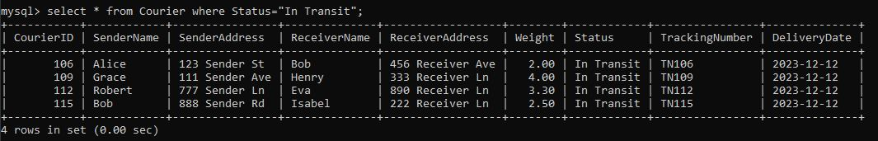

1. Calculate the total number of packages for each other.

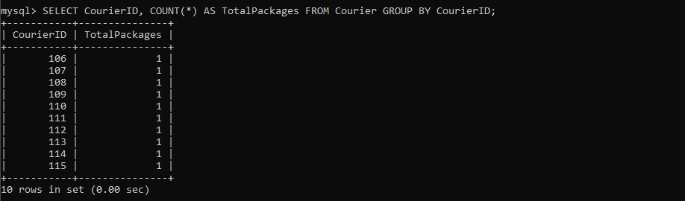

1. List all packages with a specific weight range

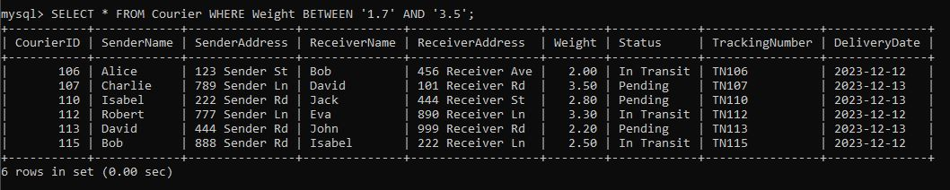

1. Retrieve employees whose names contain 'John'

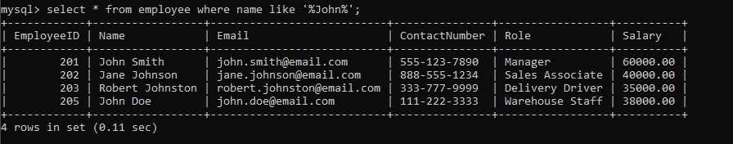

1. Retrieve all courier records with payments greater than $50.

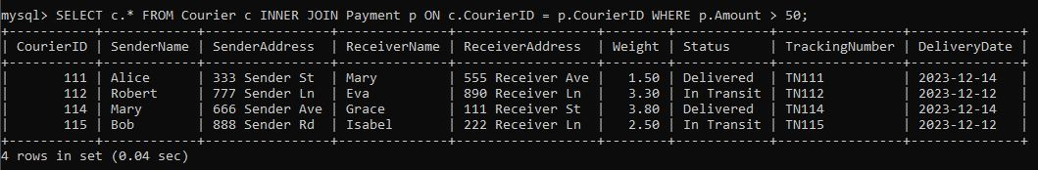

## Task – 3: GroupBy, Aggregate Functions, Having, Order By, where

1. Find the total number of couriers handled by each employee.

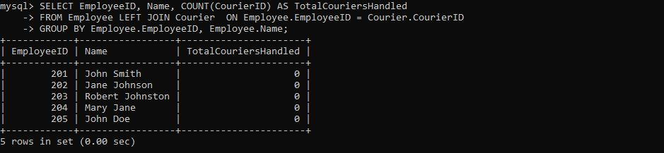

1. Calculate the total revenue generated by each location

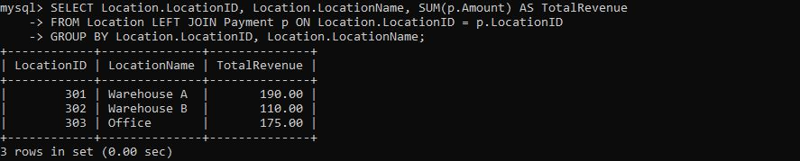

1. Find the total number of couriers delivered to each location.

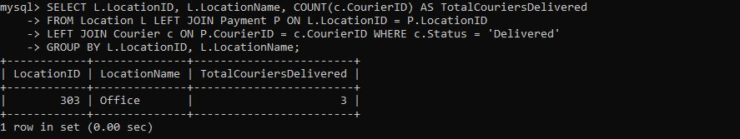

1. Find Locations with Total Payments Less Than a Certain Amount

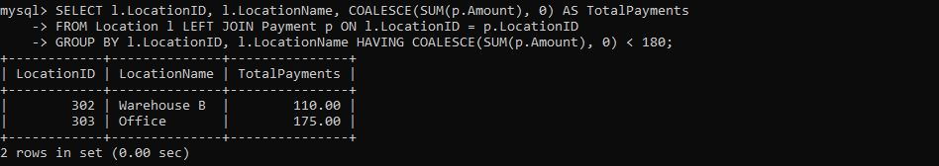

1. Calculate Total Payments per Location

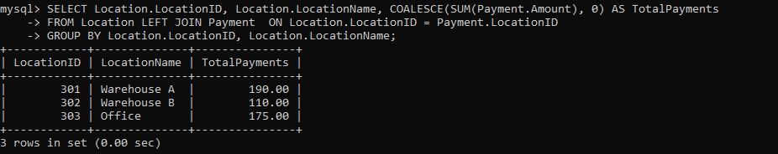

1. Retrieve couriers who have received payments totaling more than $1000 in a specific location (LocationID = X):

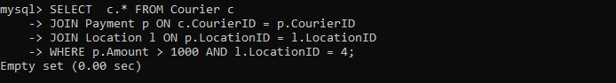

1. Retrieve couriers who have received payments totaling more than $1000 after a certain date (PaymentDate > 'YYYY-MM-DD'):

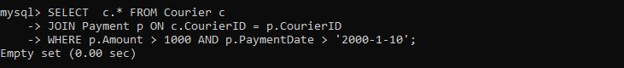

1. Retrieve locations where the total amount received is more than $5000 before a certain date (PaymentDate > 'YYYY-MM-DD')

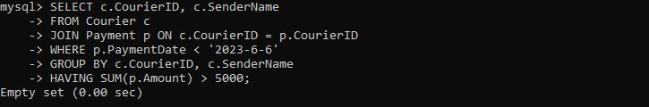

## Task – 4: Subquery and its type

1. Retrieve Payments with Courier Information

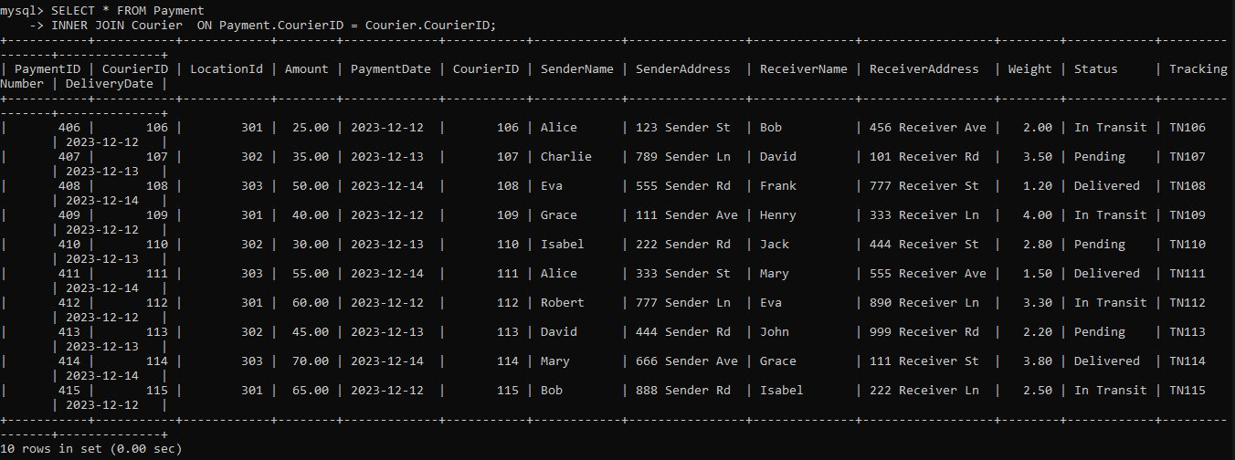

1. Retrieve Payments with Location Information

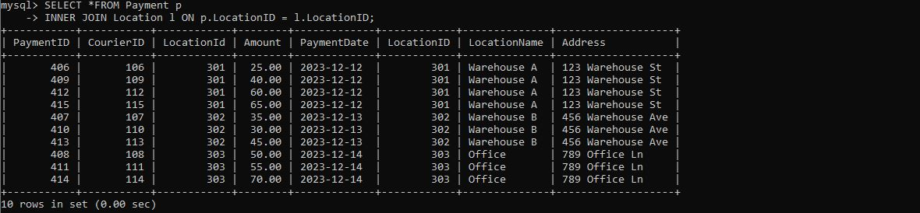

1. Retrieve Payments with Courier and Location Information

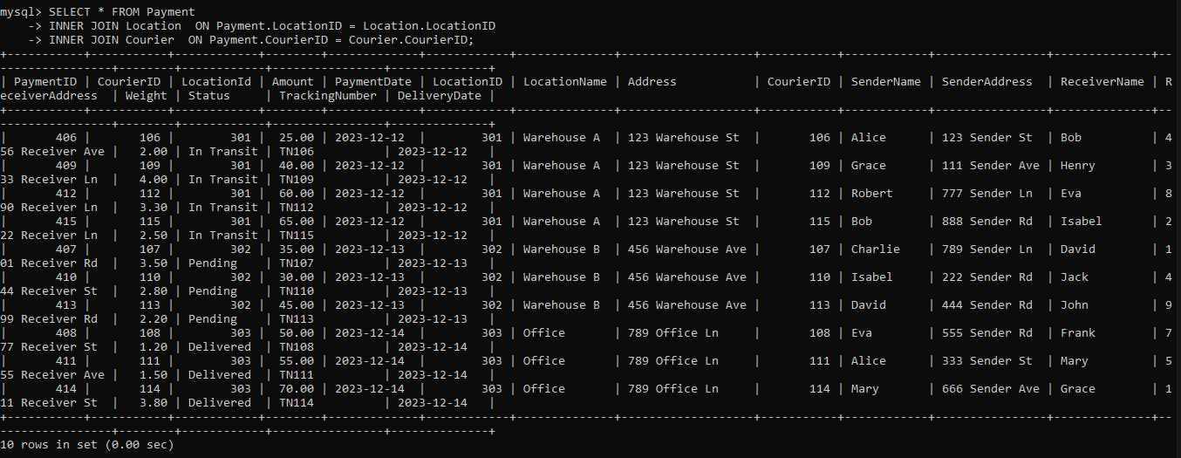

1. List all payments with courier details

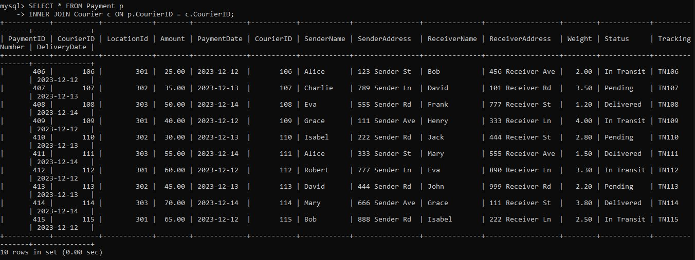

1. Total payments received for each courier

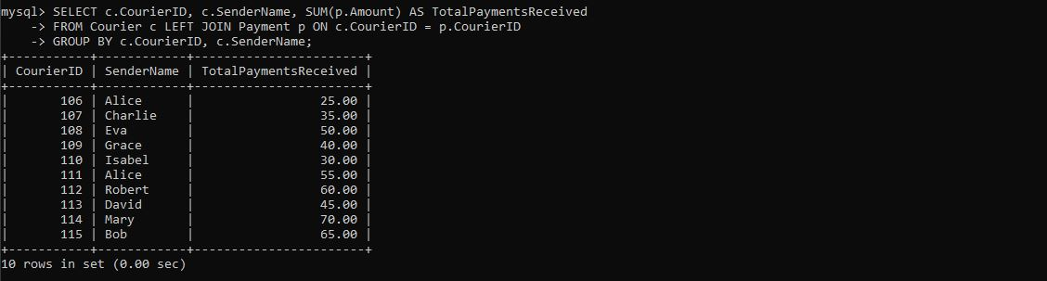

1. List payments made on a specific date

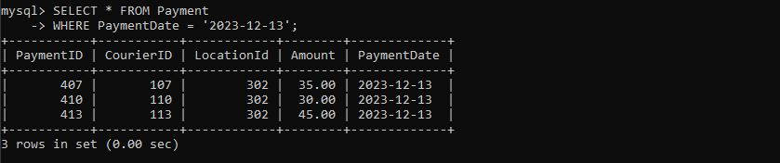

1. Get Courier Information for Each Payment

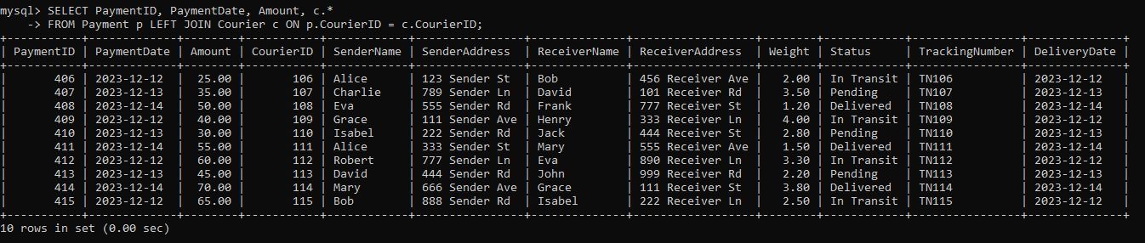

1. Get Payment Details with Location

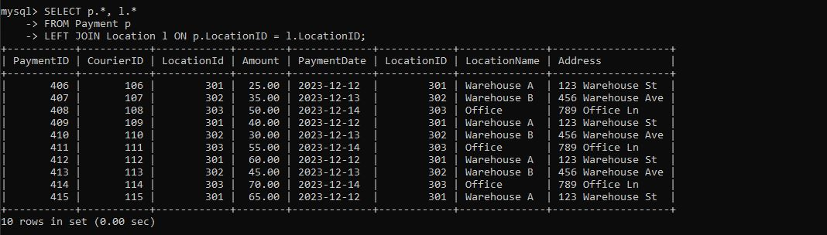

1. Calculating Total Payments for Each Courier

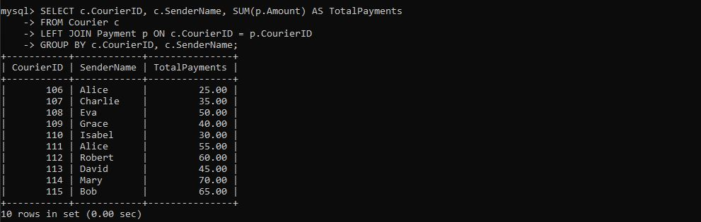

1. List Payments Within a Date Range

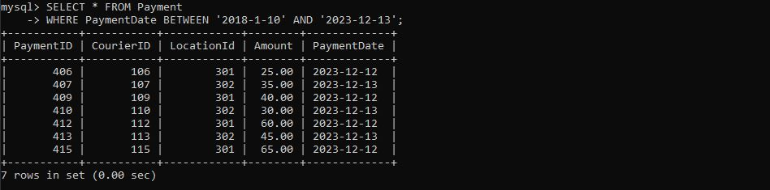

1. List all users and all courier services, showing all possible combinations.

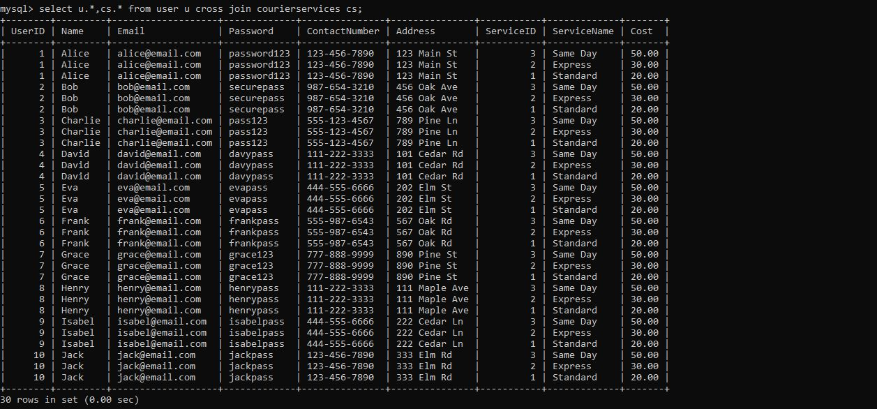

1. List all employees and all locations, showing all possible combinations:

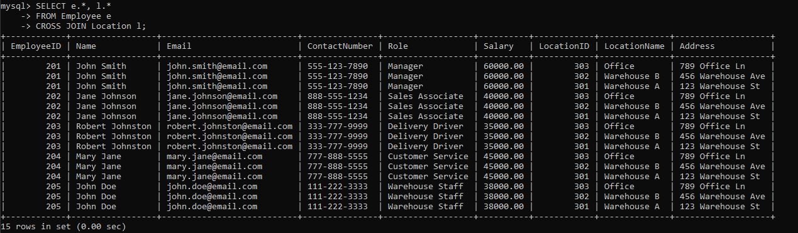

1. Retrieve a list of couriers and their corresponding sender information (if available)

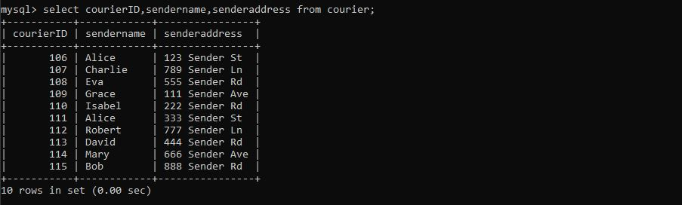

1. Retrieve a list of couriers and their corresponding receiver information (if available):

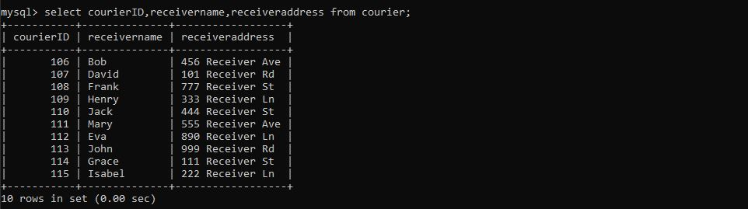

1. Retrieve a list of couriers along with the courier service details (if available):



1. Retrieve a list of employees and the number of couriers assigned to each employee:

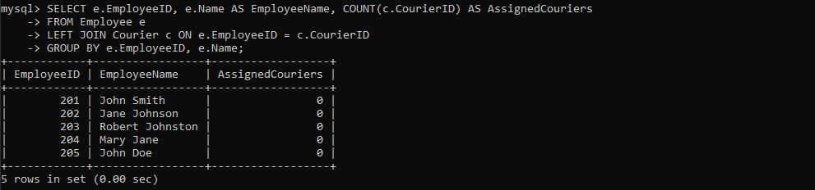

1. Retrieve a list of locations and the total payment amount received at each location:

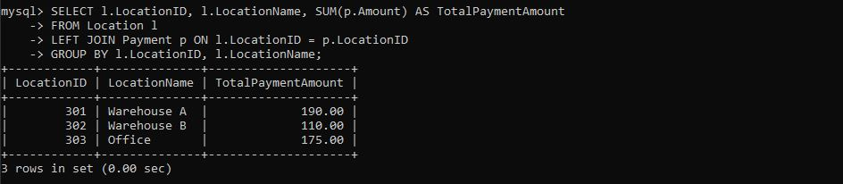

1. Retrieve all couriers sent by the same sender (based on SenderName).

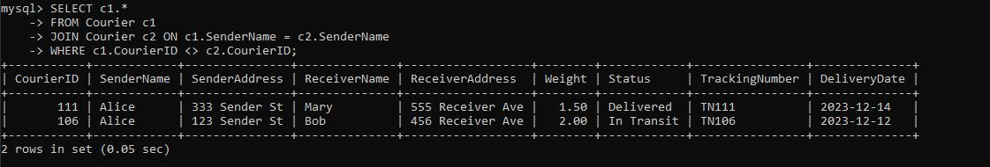

1. List all employees who share the same role.

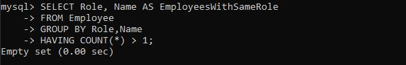

1. Retrieve all couriers sent from the same location (based on SenderAddress).

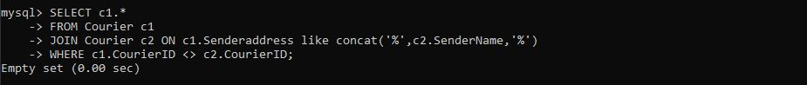

## Scope:

1. Find couriers that have a weight greater than the average weight of all couriers

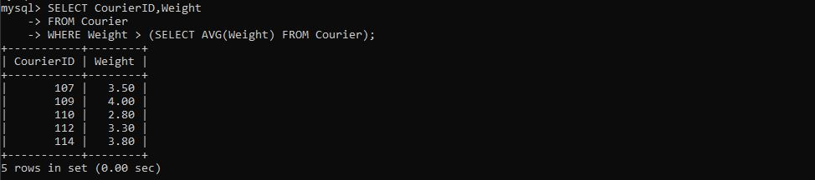

1. Find the names of all employees who have a salary greater than the average salary:

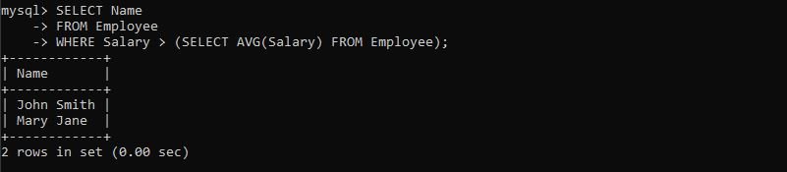

1. Find the total cost of all courier services where the cost is less than the maximum cost

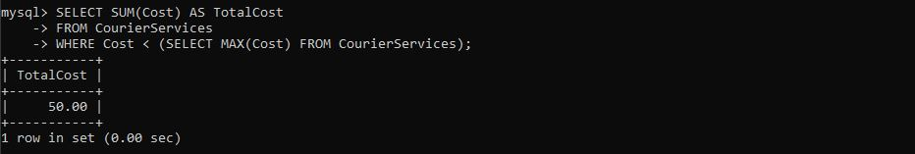

1. Find all couriers that have been paid for

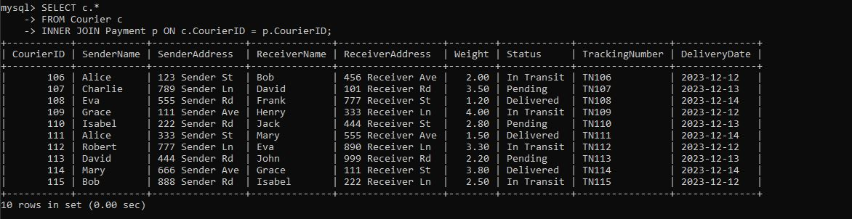

1. Find the locations where the maximum payment amount was made

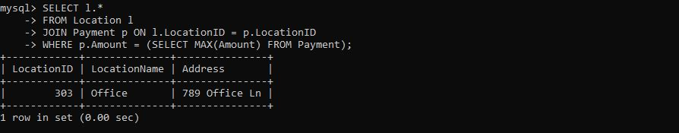

1. Find all couriers whose weight is greater than the weight of all couriers sent by a specific sender (e.g., 'SenderName'):

